Purpose

This policy details how Keon Park Kindergarten Incorporated maintains written policies and procedures that clearly communicates the service operation and reflects national and state regulatory requirements and contemporary views on evidence-based practice.



Policy Statement

## Values

Keon Park Kindergarten Incorporated is committed to:

* delivering high quality early education and care for children and families
* proactive leadership and governance of the service
* effective and efficient management systems
* a continuous improvement approach of the service and its educational program
* facilitating a shared understanding of the service’s statement of philosophy that underpins practice and decision-making.

## Scope

This policy applies to the approved provider, persons with management or control, nominated supervisor, persons in day-to-day charge, early childhood teachers, educators, staff, students, volunteers, parents/guardians, children, and others attending Keon Park Kindergarten Incorporated .

|  |  |  |  |  |  |
| --- | --- | --- | --- | --- | --- |
| Responsibilities | Approved provider and persons with management or control | Nominated supervisor and persons in day-to-day charge | Early childhood teacher, educators and all other staff | Parents/guardians | Contractors, volunteers and students |
| **R** indicates legislation requirement, and should not be deleted | | | | | |
| Ensuring that the service operates in compliance with the Education and Cares Services National Law, the Education and Cares Services National Regulations and the National Quality Standards | **R** | √ | √ |  | √ |
| Ensuring that the service has in place policies and procedures in relation to the matters set out in Regulations 168 (2) | **R** | √ |  |  |  |
| Ensuring adequate systems are in place to maintain the compliant operation of the service | √ | √ |  |  |  |
| Taking reasonable steps to ensure that nominated supervisors and staff members of, and volunteers at Keon Park Kindergarten Incorporated follow the policies and procedures required under Regulation 168 | **R** |  |  |  |  |
| Ensuring that policies and procedures are well-documented, maintained and easily accessible to staff members and families (Regulations 171) | **R** | √ |  |  |  |
| Ensuring families are notified at least 14 days before making changes to policies and procedures that may have significant impact on:   * the service’s provision of education and care to any child enrolled at the service; or * the family’s ability to utilise that service (Regulations 172) | **R** | √ |  |  |  |
| Ensuring that families are notified at least 14 days before making any change to the Fees Policy that will affect the fees charged or the way in which fees are collected (Regulation 171 (2)) | **R** | √ |  |  |  |
| Ensuring families are notified as soon as practicable after making a change to policies listed under Regulations 168 if they believe the notice period would pose a risk to the safety, health of wellbeing of the children and staff at the service (Regulation 172 (3)) | **R** | √ |  |  |  |
| Ensuring that the service’s statement of philosophy is reflected within the services suite of policies and procedures | √ | √ | √ |  |  |
| Developing a sustainable policy review schedule (refer to Attachment 2) | √ | √ |  |  |  |
| Establishing a Working Group and delegating a Responsible Person/s for each policy and procedure to be reviewed within the scheduled cycle (refer to Attachment 1) | √ | √ |  |  |  |
| Ensuring version control and amendments are documented (refer to ELAA’ s Version Control Guide – sources) | √ | √ | √ |  |  |
| Regularly reviewing policies and procedures in collaboration with families to support a shared understanding of the service’s practices | √ | √ | √ | √ | √ |
| Reviewing final drafts and provide endorsement | √ |  |  |  |  |



Procedures

There are numerous models of policy review processes. ELAA has modified the Bridgman and Davis (2000) policy cycle for implementation by early childhood education and care services. This policy cycle consists of eight stages, as shown in the diagram below.

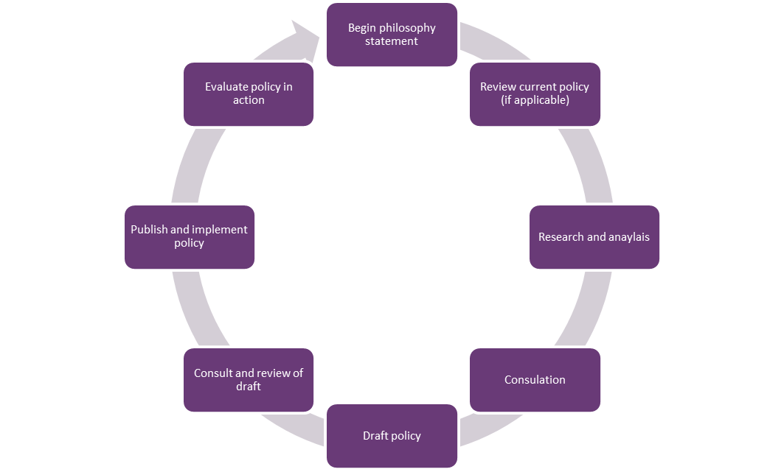



Regulatory & legislative

Environment

Staff, committee/approved provider, parents/guardians, children, the community

Philosophy

Diagram one

Background and Legislation

## Background

Efficient and effective policies and procedures are an essential part of a service’s operation. They ensure compliance with laws and regulations, provide a road map for the day-to-day operations and set standards of behaviour, conduct and performance. When followed, the service can run smoothly, and any risks can be identified in a timely manner. Policies and procedures reduce liability risk and promote a safe and healthy environment for all users of the service.

The Education and Care Service National Regulations, 2011 states that the approved provider of an education and care service must ensure that the service has policies and procedures in place as set out in Regulation 168 (2).

While the National Regulations and the National Quality Standards (NQS) do not specify how often the review of policies and procedures should occur, policies should be reviewed regularly to meet the changing needs of the service and continued compliance with legislation.

As a general rule, every policy should be reviewed regularly (every one to three years), when legislative changes occur, and if there’s a change of processes or when an incident occurs that may also impact on the policy review process. Policies can be prioritised for review according to how often the content is expected to change. Policies should be up to date with current research and contemporary views on evidence-based practice, and support a shared understanding of a service’s practices, purpose and philosophy.

## Legislation and Standards

Relevant legislation and standards include but are not limited to:

* Education and Care Services National Law Act 2010
* Education and Care Services National Regulations 2011
* National Quality Standard, 2020

The most current amendments to listed legislation can be found at:

* Victorian Legislation – Victorian Law Today: [www.legislation.vic.gov.au](http://www.legislation.vic.gov.au)
* Commonwealth Legislation – Federal Register of Legislation: [www.legislation.gov.au](http://www.legislation.gov.au)



Definitions

The terms defined in this section relate specifically to this policy. For regularly used terms e.g. Approved provider, Nominated supervisor, Notifiable complaints, Serious incidents, Duty of care, etc. refer to the Definitions file of the PolicyWorks catalogue.

**Evidence based practice:** The process of combining best available research, knowledge from professional experts, and data proven to achieve positive outcomes for children and families.

**Policy:** High-level guidelines that are underpinned by legislation and define the culture of the service by shaping decisions and providing a framework for daily activities.

**Procedure:** Details the action to be taken to address the policy and outlines the implementation process. It facilitates decision making, provides consistency and independence and enhances effective management and teamwork.

**Philosophy statement:** A statement about the beliefs, attitudes, core principles and values that underpin practices in your service. It should reflect the guiding principles outlined in the Education and Care Service’s National Law Act 2010 and the Early Years Learning Framework and Framework.

**Working group:** For the purpose of this policy a working group can be made up of stakeholders possessing the relevant knowledge and skills to review and adopt updates policies.

Sources and Related Policies

## Sources

* Guide to the Education and Care Services National Law and the Education and Care Services National Regulations 2011: [www.acecqa.gov.au](https://www.acecqa.gov.au/)
* Guide to the National Quality Standard: [www.acecqa.gov.au](https://www.acecqa.gov.au/)
* ELAA’s Helpful resources for policy development: [https://elaa.org.au/resources/free-resources](https://elaa.org.au/resources/free-resources/helpful-resources-for-policy-development/)
* ELAA’s Version Control Guide: [My Memberships](https://elaa.org.au/login/?url=https://elaa.org.au/account/) – PolicyWorks – File Download

## Related Policies

* Fees
* Governance and Management of the Service

Evaluation

In order to assess whether the values and purposes of the policy have been achieved, the approved provider will:

* regularly seek feedback from everyone affected by the policy regarding its effectiveness
* monitor the implementation, compliance, complaints and incidents in relation to this policy
* keep the policy up to date with current legislation, research, policy and best practice
* revise the policy and procedures as part of the service’s policy review cycle, or as required



Attachments

* Attachment 1: Policy review procedure
* Attachment 2: Policy review schedule sample

Authorisation

This policy was adopted by the approved provider of Keon Park Kindergarten Incorporated on August 2024.

**REVIEW DATE:** August 2027

Attachment 1. Policy review procedure

**Approved Provider:**

* Establish a Working Group and delegate a Responsible Person/s for each policy to be reviewed within the review schedule (refer to Attachment 2).
* Contact the Responsible Person/s advising them of the current policies requiring review

**Responsible Person:**

Review allocated policy and consider the following:

* is there new legislation, regulation, awards, codes of practice and/or guidelines that will impact on policy?
* has an incident occurred, or has a concern, complaint or issue been raised, that has prompted the need for a policy or the review of a policy?
* is the current practice fair, equitable and effective?
* has there been a change to the service’s model of service delivery or philosophy?
* how will any changes impact on children, families, educators, staff and management?
* what are the advantages and/or disadvantages of the existing policy?
* does the current policy reflect the:
  + service’s philosophy
  + long-term goals
  + operational processes and procedures
  + workplace protocols
  + work practices
* does this policy reflect best practice?
* what procedures are in place to support the implementation of the policy?

**Responsible Person:**

* To review the policy within the required timeframe (refer to Attachment 2)
* Make any required amendments to the policy, (as outlined above) using track changes and version control.
* Submit updated policy to stakeholders for consultation
* Gather feedback and comments from stakeholders, this can be via:
  + face-to-face
  + meetings
  + emails
  + suggestion boxes
  + providing a copy of the policy and an explanation of the type of comments sought
* Make any further amendments (if relevant) to the policy, and to present the final draft to Working Group for review and adoption.

**Working Group:**

* Review the policy submitted by the allocated Responsible Person
* At this stage the Working Group can:
  + adopt the draft policy
  + adopt the draft policy with minor amendments
  + request more information.
* Once the policy has been finalised and adopted, ensure families are notified at least 14 days in advance of any changes to a policy or procedure that may impact significantly on the education and care received by their child, on the family’s ability to utilise the service, or on the fees or the way fees are collected.
* After the 14 days, if no further changes are required the policy can be endorsed by the Approved Provider.

**Approved Provider:**

* Publish and implement the newly endorsed policy
* Document changes in the service’s Quality Improvement Plan
* Make the updated policy available/accessible to those who require it ***(Regulations 171)***
* Monitor the implementation of the revised policy to measure its impact and determine whether it is meeting intended outcomes. It is also important to ensure that there are no unintended consequences, or difficulties with the policy which may require modification or discontinuation

Attachment 2. Policy review schedule sample

* The below table is a reference guide only which services can adopt or modify as needed.
* The table reflects a three-year review cycle, illustrating how all policies would be reviewed in that time. ELAA recommends that some policies are reviewed every twelve months. These include:
  + Enrolment and Orientation (Funder Kindergarten, Free Kindergarten and Long Day Care)
  + Fees (Funder Kindergarten, Long Day Care and Free Kindergarten)
  + Privacy and Confidentiality
  + Child Safe Environment and Wellbeing
  + Emergency and Evacuations
  + Determining Responsible Person
* It is also important to consider and set timeframes for each stage of the policy review cycle (refer to Diagram one). This will ensure consistent and sustainable policy maintenance.

Please refer to the PolicyWorks 3 Year Review Schedule excel file for a comprehensive list